FOR IMMEDIATE RELEASE Contact: Crystal Patriarche, BookSparks
crystal@booksparkspr.com | 480-650-1688

Transmedia Author Alane Adams Wins Big in Children’s Book Awards
Alane Adams picks up awards for Kalifus Rising and The Egg Thief

August 10, 2017 – The captivating second installment of The Legends of Orkney series, Kalifus Rising, and the heartwarming children’s picture book, The Egg Thief, was a stand-out in this award season, picking up numerous literary honors from nationally recognized children’s book awards.

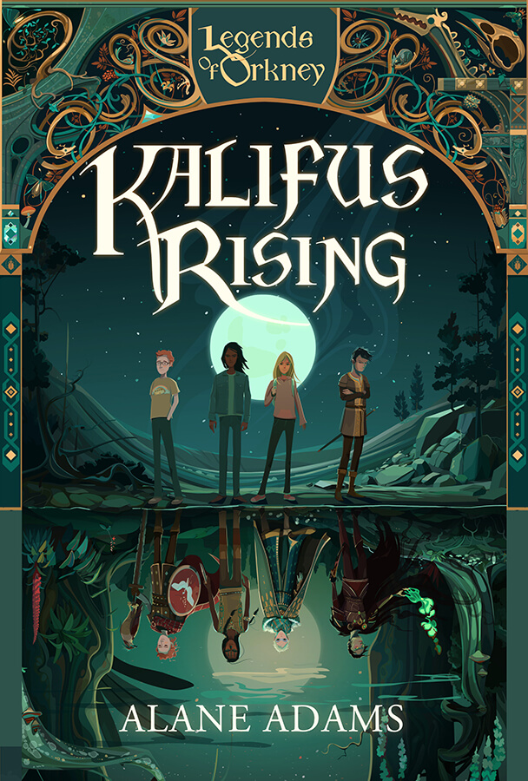
Kalifus Rising won USA Best Book Awards in two categories: “Best Cover Design: Fiction” and “Children’s Fiction.” Additionally, the book was chosen as a finalist in the “Juvenile Fiction” category for the Foreword INDIES Book of the Year, which celebrates the best in independent publishing. In the IBPA Benjamin Franklin Awards, the book took gold in the "Young Reader: Fiction (8-12 years)" and "Cover Design: Children's/Young Adult" categories. It was also the 2016 Next Generation Indie Book Awards winner in the “Children’s/Juvenile Fiction” category.

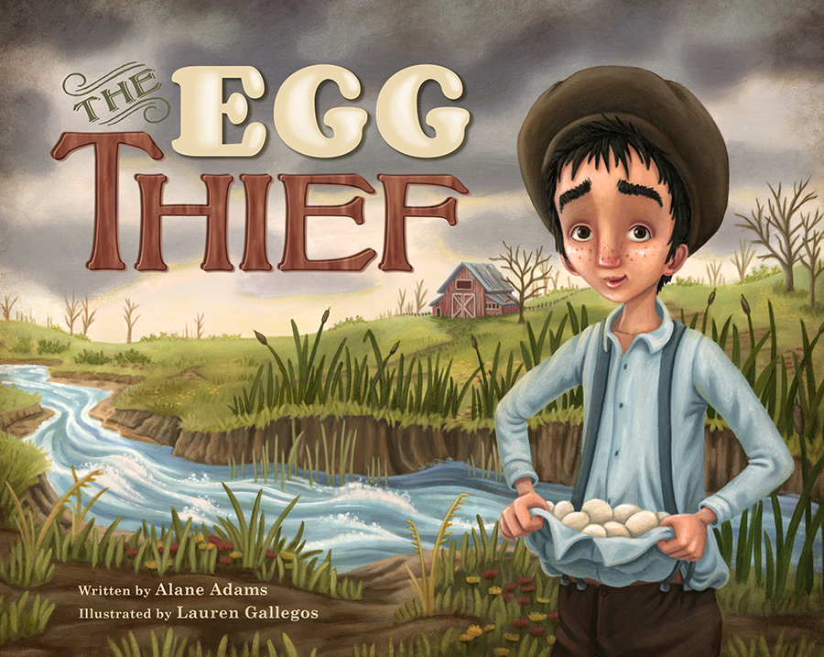

The Egg Thief also swept multiple awards, including being awarded as a Kirkus Review Best Book of 2016. The children’s picture book was a finalist for the 2016 Forward INDIES Book of the Year and a Silver Award winner in the IBPA Benjamin Franklin Awards for the “Children’s Picture Book (4-7 years)” category.

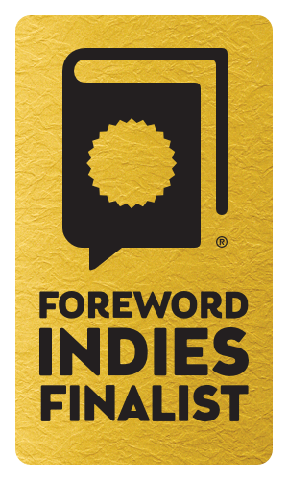
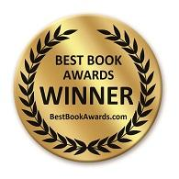
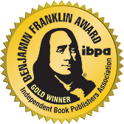

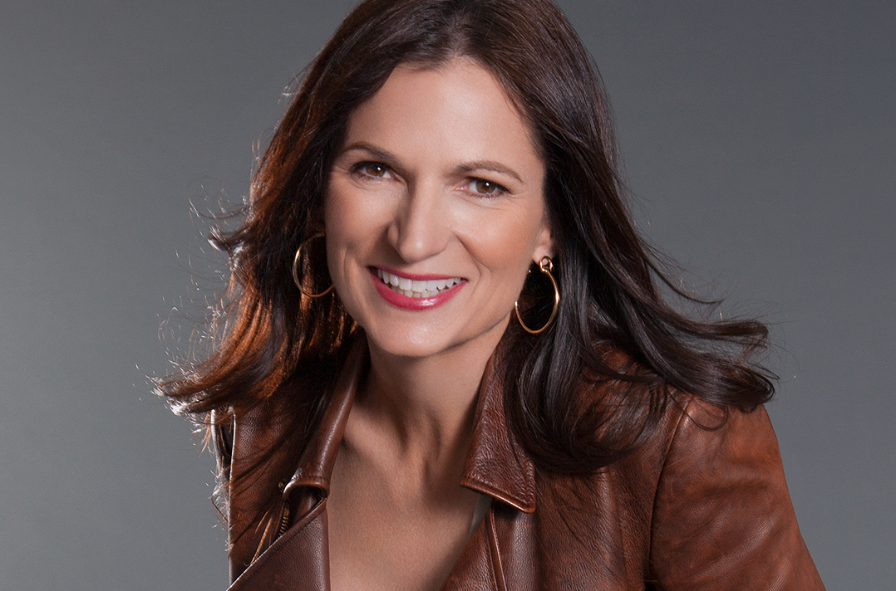
Alane Adams is a social entrepreneur, philanthropist, professor, award-winning author and an avid literacy advocate. After spending decades balancing budgets for the family business, she founded the Rise Up Foundation focusing on global poverty issues and particularly their effect on children. A Masters Degree in Diplomacy and several field visits with UNICEF later, Alane witnessed firsthand the importance of education and literacy in the battle to end extreme poverty and shifted the focus of her foundation to improving and supporting literacy efforts. Her passion for literacy and children came together when her 12-year-old son Alex challenged her to write a book he could read. The Legends of Orkney book series was born and she hasn’t stopped writing since. The Red Sun and Kalifus Rising are the first two books in her Legends of Orkney middle grade book series, with the final installment in the series, Raven God, publishing this September. In 2015, Alane teamed up with Artifact Technologies to create BattleKasters, a live- action adventure mobile game based on The Legends of Orkney book series. In addition, Alane created an award-winning picture book series, which includes The Coal Thief and The Egg Thief, and this winter Alane is publishing The Santa Thief.

Alane is a proud member of the Society of Children’s Book Writers and Illustrators, the International Reading Association, The Literacy Research Association, and the California Reading Association.

###

